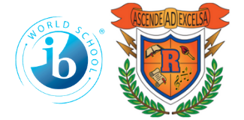
Ridgeway International Baccalaureate
Middle World Optional School
2022-2023
World Language School Supply List

Parents/Guardians:

We appreciate you helping us to get the school year off to a great start by helping us with the supplies requested on this supply list. We look forward to meeting you and your child.

2 composition notebooks
2 boxes of Pencils No. 2
2 Highlighters
1 Spanish Dictionary any brand.

**Exploratory Classes (Art, Vocal Music, Band, STEM, Strings) will need other supplies which will be communicated when students attend assigned classes!!**

